Nice, you got past the first one. But cracking my passwords won’t always be so easy, cause now I got smart, and I used a thing called salt for this one.
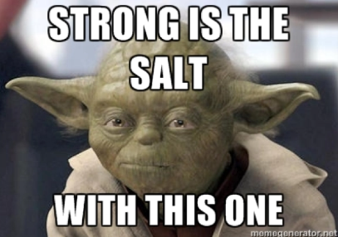
When I put salt on, it adds some randomness to my password before hashing. You’ll have to manually adjust your wordlist to account for that. Some bash or python could do that for you real quick. I’ll even give you the salt I used, it was “xpepperx” added to the beginning of the password. I was kinda lazy picking a new password though… so if you get around the salt, then you will crack this one as easily as you did the first one…
Also, this time, you’ll need to get the hash from the zip file first before you can crack it… I hear there’s a guy named John who can help you with that…
Good luck!

